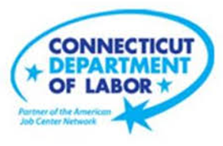

**NEW WEEKLY JOB POSTINGS FROM   
HELP WANTED ONLINE  
Office of Research**

**Week Ending March 4th, 2023: Weekly New Ads Hold Steady at 5,800.**WETHERSFIELD, March 10th, 2023 – During the week ending March 4th, there were 5,800 new postings, down 29 new ads or 0.5% from a week ago. This slight topline shift is the net result of 10 industries decreasing by a combined 379 new ads and 11 industries increasing over the week by a combined 350 new ads. The three industries with the largest decreases were Health Care & Social Assistance (-129 new ads or -24%), Construction (-50 new ads or -54%), and Finance & Insurance (-46 new ads or -9%). Employers with the largest over-the-week decreases include The Travelers   
(-187 new ads), Hartford Healthcare (-99 new ads), and Dunkin’ (-64 new ads). Employers with the largest increases include Trinity Health (+63 new ads), Restaurant Depot (+52 new ads), and The Greater Hartford YMCA (+36 new ads). The graph below illustrates total new ads nationwide and within Connecticut. The current week is shown below to be the lowest of 2023 for the state, while the U.S. had an increase of 4.9% from a week ago.  
  
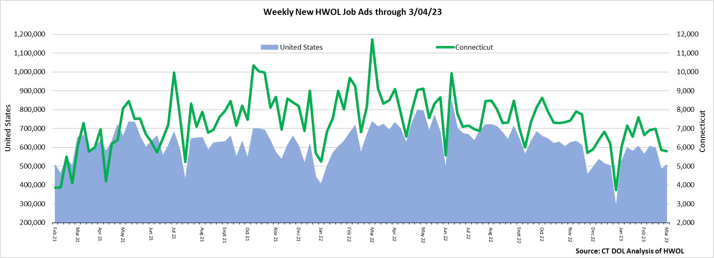  
**Industries** with the most new postings include Health Care & Social Assistance, Retail Trade, and Finance & Insurance.

**Occupations** with the most new postings include Registered Nurses, Retail Salespersons, and First-Line Supervisors of Retail Sales Workers.

**Employers** with the most new postings include Cigna Corporation, Trinity Health, and the State of Connecticut.

**The three industries with the most new job postings were:**

* **Health Care & Social Assistance** (1,320 new postings, -9% over the week)
* **Retail Trade** (503 new postings, +10% over the week)
* **Finance & Insurance** (489 new postings, -9% over the week)

   
 During the week ending March 4th, 2023, the slight overall new ad decrease overlays larger shifts within specific industries in the state. Eleven industries had over-the-week increases and ten had decreases, the largest of each respectively were Accommodation & Food Services (+83 new ads) and Health Care & Social Assitance (-129 new ads). Over four weeks, total ads are down 13%, with 15 of 21 industries showing declines. The largest four-week decline occurred in Health Care & Social Assistance, down 410 new ads. Among the six industries with four-week increases, the largest was Other Services, up 41 new ads.   
  
 For more information on total job ads by industry for Connecticut and its labor market areas, see the monthly report available here: <https://www1.ctdol.state.ct.us/lmi/hwol.asp>

**New Job Postings by Occupation** 

**The occupations with the most new postings were:**

* Registered Nurses (314 new postings, -16% over the week)
* Retail Salespersons (174 new postings, +19% over the week)
* First-Line Supervisors of Retail Sales Workers (156 new postings, +20% over the week)

**Employers with the Most New Job Postings** Employers with the most new job postings during the week ending March 4th were mostly within Retail Trade, Health Care & Social Assistance, and Finance & Insurance. Retail Trade accounted for seven of the top 25 employers. The 25 employers shown above combined account for 956 of total job ads or 16 percent of all new ads. A week ago, the top 25 employers accounted for 1,356 job ads, or 23 percent of all new ads. Sixteen employers in the top 25 increased over the week, two were unchanged, and seven decreased. Among the 25 employers with the most ads, the largest increase occurred at Trinity Health (+63 new ads) and the largest decrease occurred at Hartford Healthcare (-99 new ads).  
  
**What is HWOL?**The **Conference Board Help Wanted Online**® Data Series (HWOL) measures the number of new, first-time Online job postings and jobs reposted from the previous month for over 16,000 Internet job boards, corporate boards, and smaller job sites that serve niche markets and smaller geographic areas. To view more HWOL data, go to: <https://www1.ctdol.state.ct.us/lmi/hwol.asp>